WWW.JMORGANMUSIC.COM

J. Morgan Short Bio
J. Morgan is a prolific rhyme slinger based in the Bay Area. The emcee has been making noise throughout California and beyond with his tireless work ethic and consistency. He is equipped with vivid lyrics, quality production and exceptional rhyming skills. J. Morgan’s lyrics convey a musical diary of sorts; his records are fun, honest, personal and touch on matters close to the heart. J. Morgan matches these songs with cinematic videos that he executive produces. Over the past few years, J. Morgan has been consistently headlining his own shows and supporting touring artists like Andre Nikatina, J.Lately, Equipto, Afroman, Karma Knows, Drama Duo, ¡Mayday! and Berner. J. Morgan’s most recent EP series “Demons” featured Berner, Shiesty, Allen Kass and Stevieboy. J. Morgan’s most recent album “Can I Live” was released July 1^{st,} 2019 and can be streamed or downloaded from any music store online. His newest album features Lil B, Locksmith, Stinje, J.Lately, Andrezia, DisMissedFit and more. J. Morgan released 7 music videos from the Can I Live album which can be viewed on youtube.

Photos
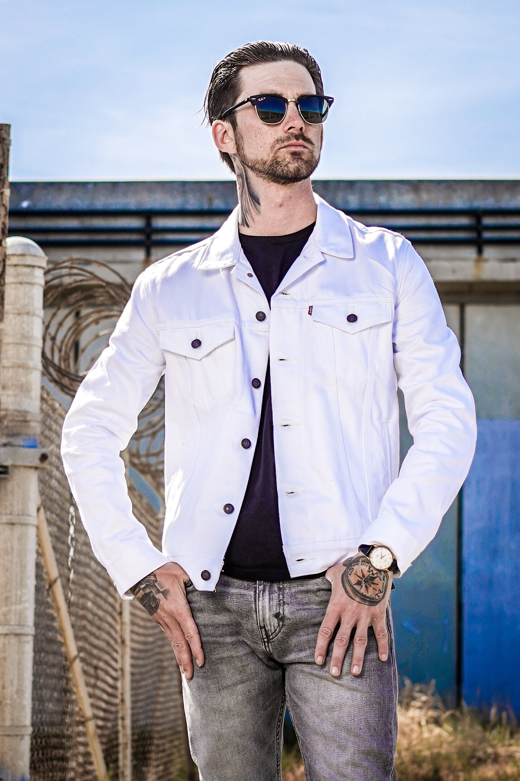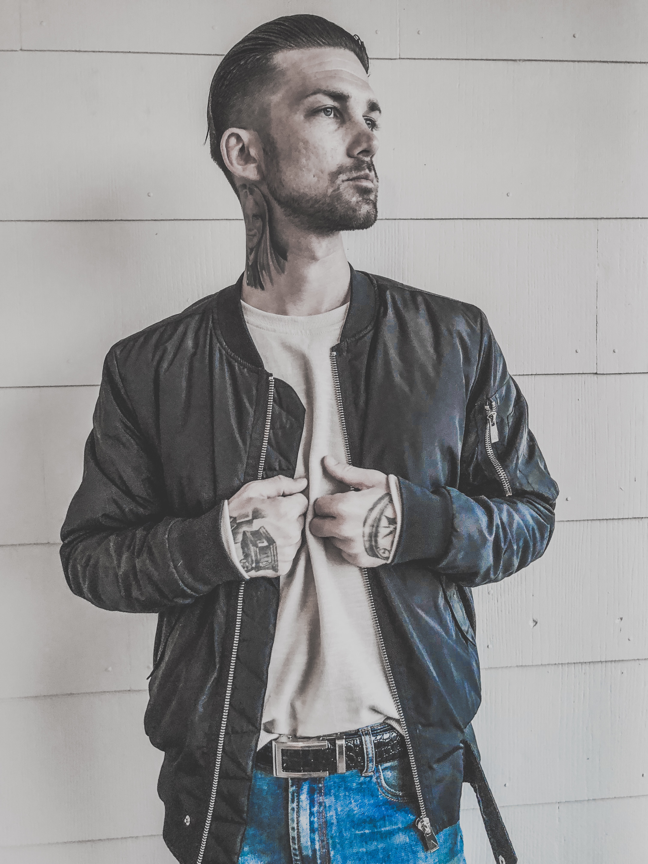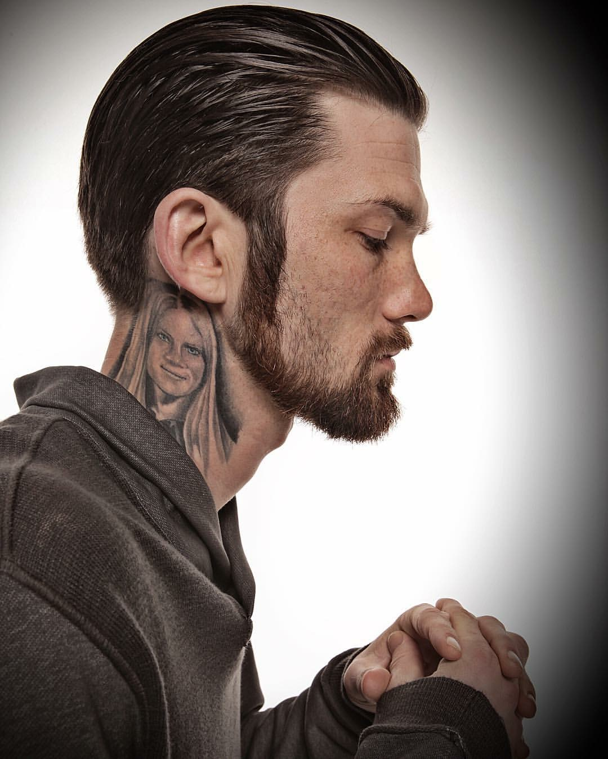
More photos

Music Videos
Can I Live
Secret Sauce
James Brown Bad
Real Love (feat. Monét)
Party Like Your Last Day (feat. Allen Kass)
Somebody Like You

Discography
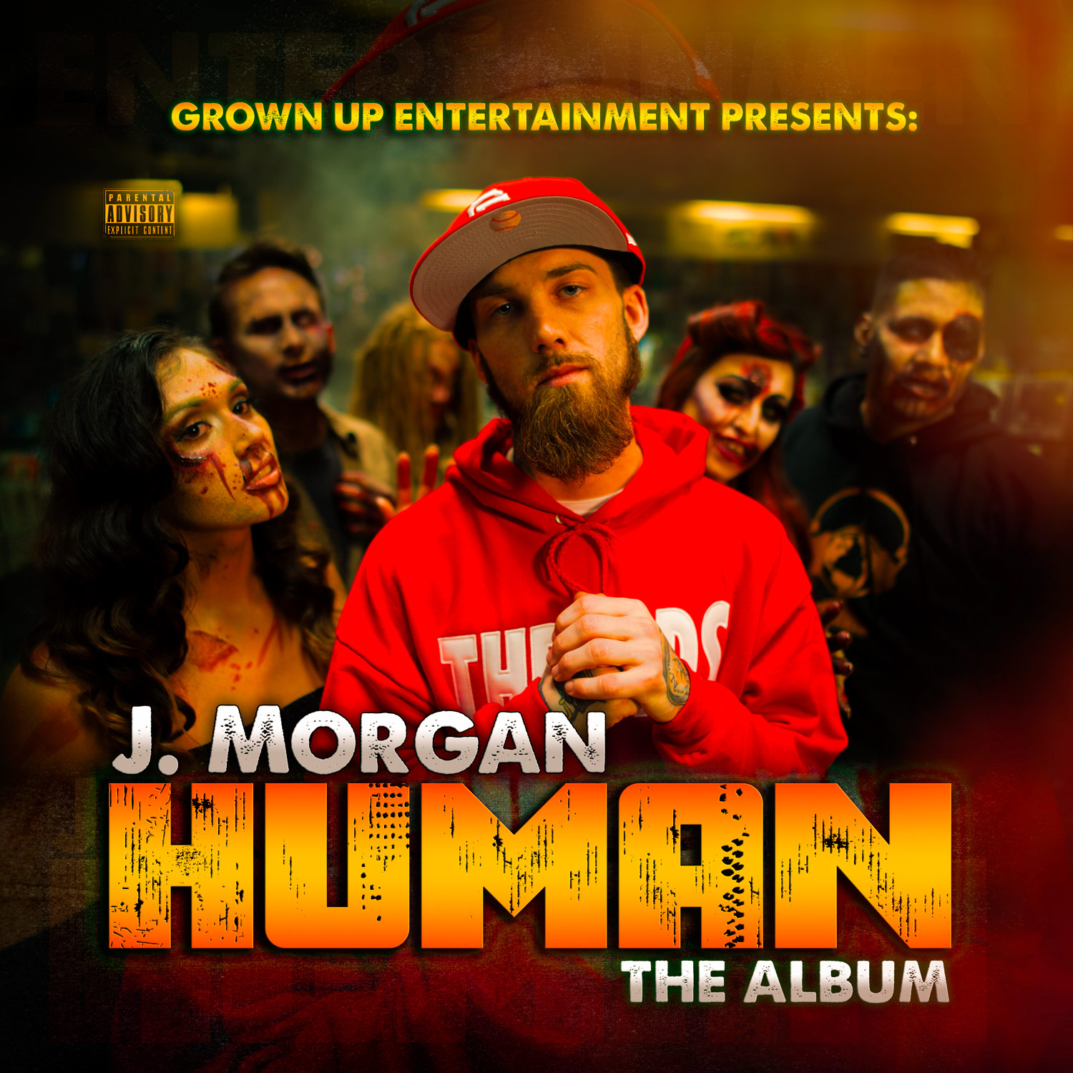
2015 Human
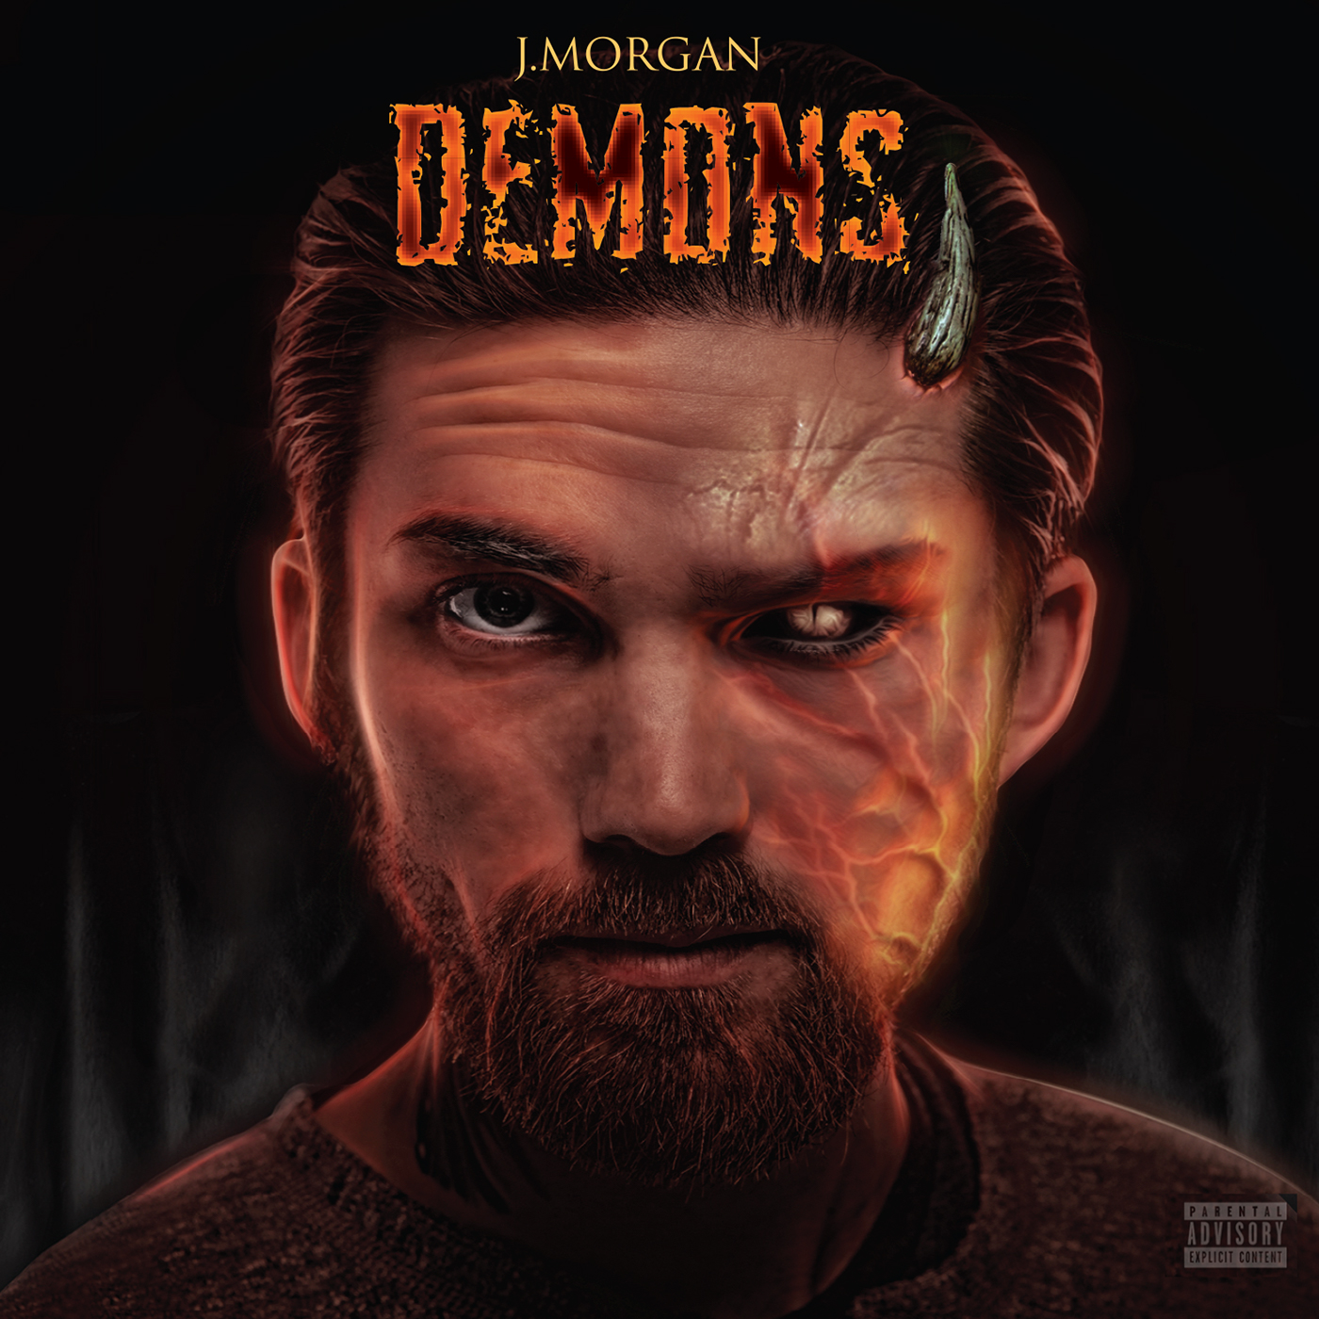
2016 Demons Part 1
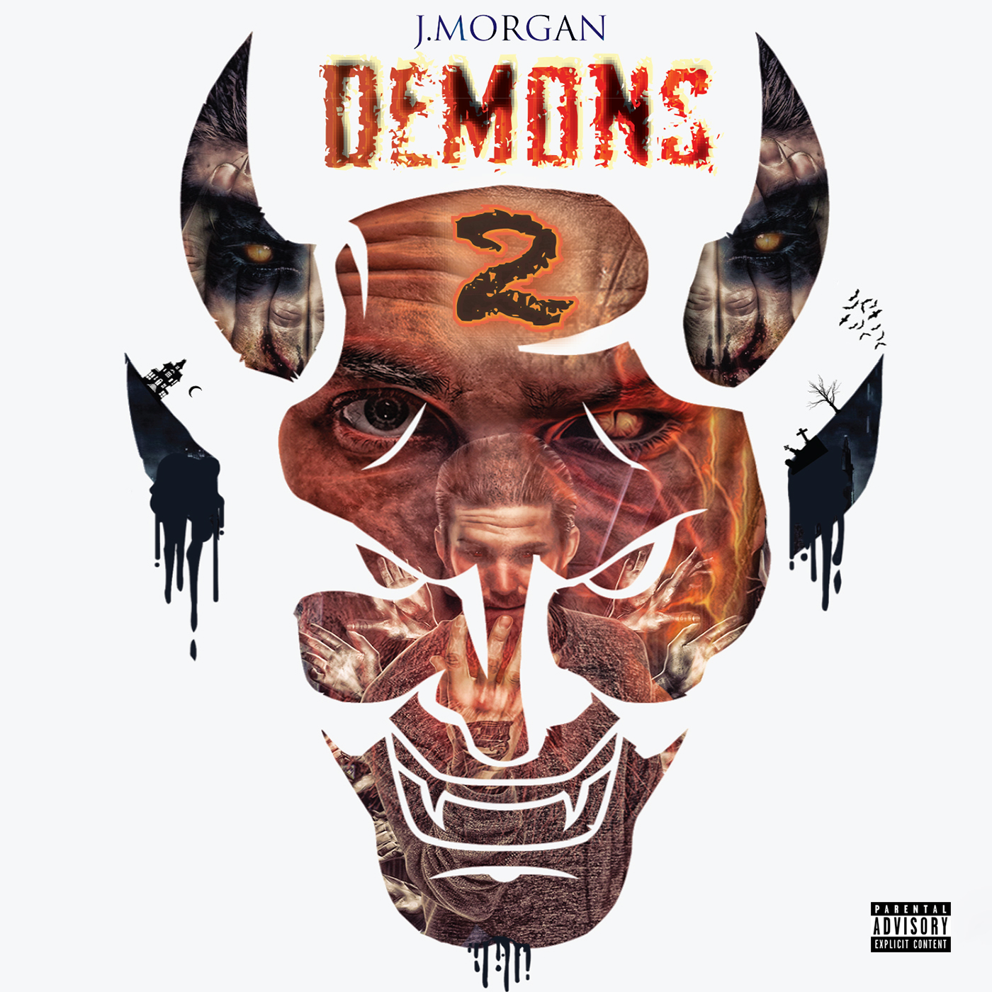
2016 Demons Part 2
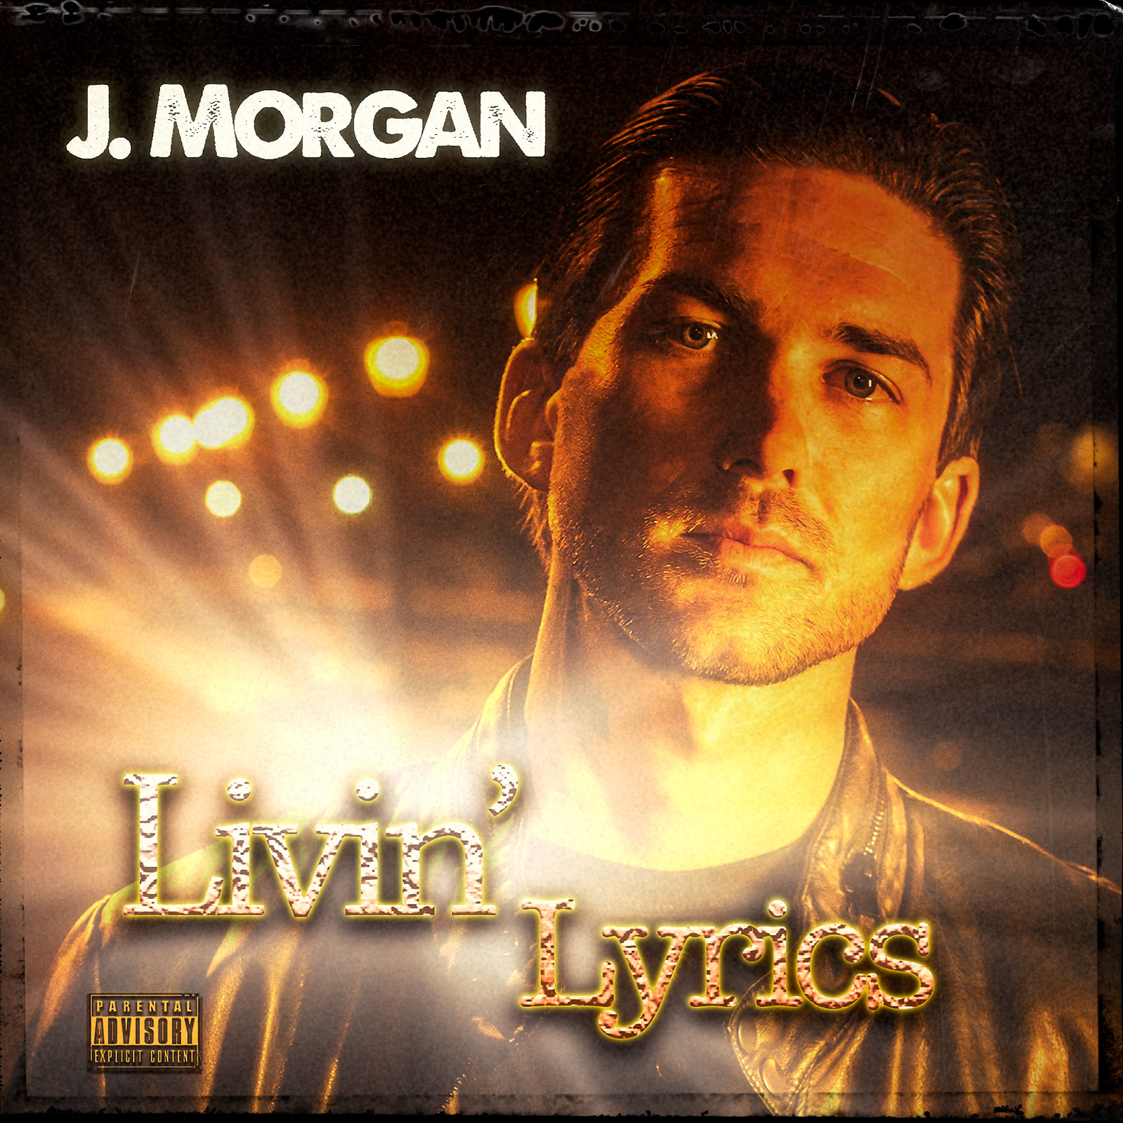
2017 Livin’ Lyrics
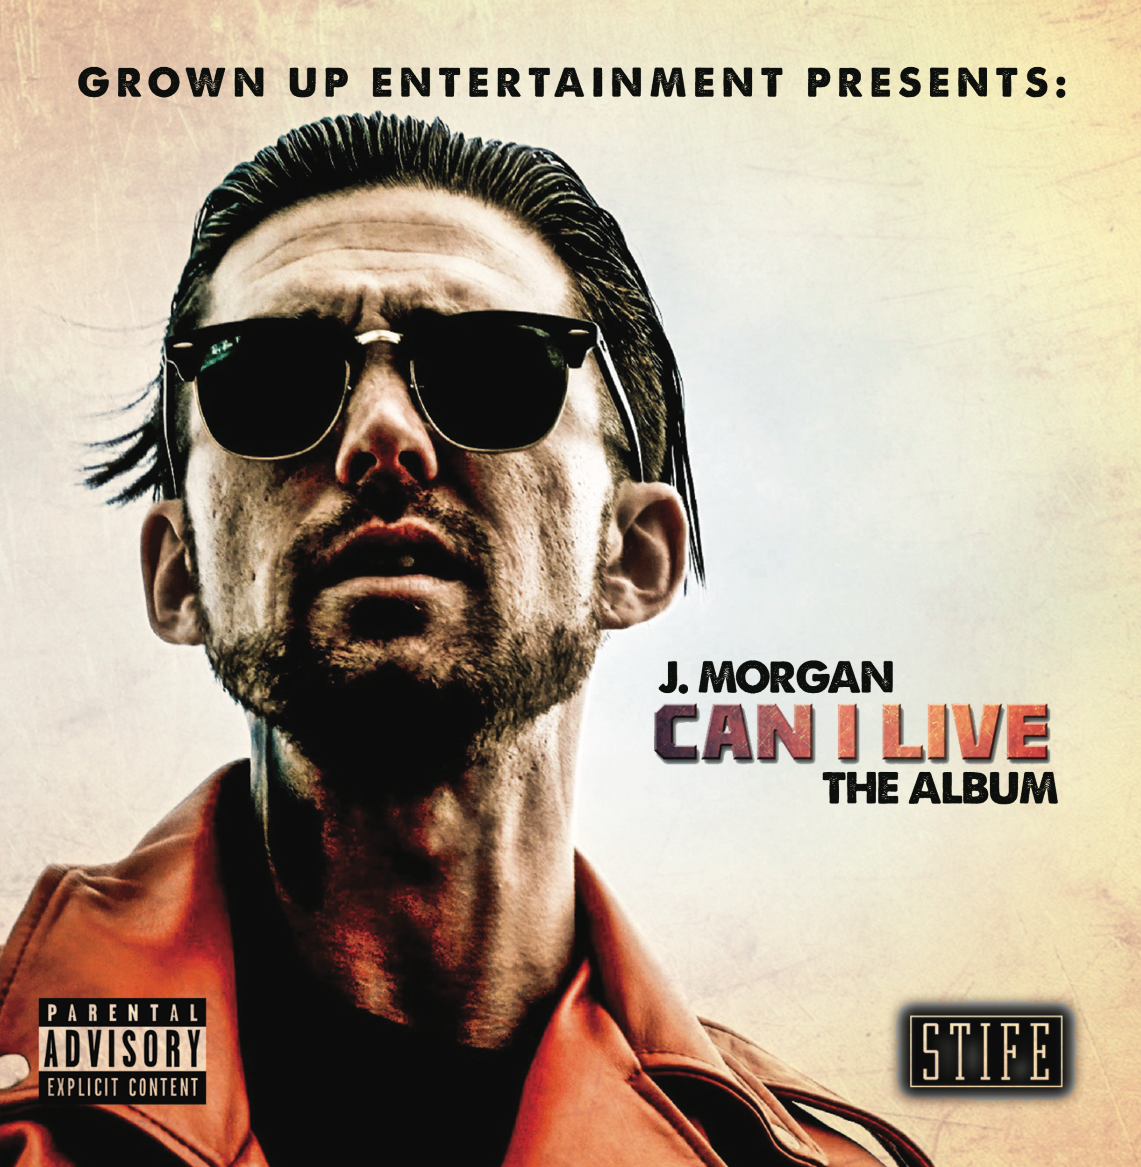
2019 Can I Live
Live Video
Lost On Main, Chico, California
Brick & Mortar, San Francisco, California
El Rio, San Francisco, California
Blue Lagoon, Santa Cruz, California

Music
Spotify
Soundcloud
Apple Music
Tidal

Social Media
Website
Facebook
Instagram
Twitter

Press
Vent Magazine
Dunn Deal PR
Skilly Magazine
Occhi Magazine

J. Morgan Full Bio
J. Morgan, born Jonathan Albert Morgan, is an American rapper from the San Francisco Bay Area. Jonathan entered the hip hop scene under the alias J-Doe (John Doe) in 2010 with his debut mix tape, Money Be Da Motivation, presented by Goldtoes Entertainment. He is better known for his more recent releases as J. Morgan such as Human, Demons, Livin' Lyrics and a variety of self written/produced music videos cleverly paired with captivating songs. J-Doe's name switch came in 2015 and was motivated by his growth as an artist. The name change was symbolic in the sense that J. Morgan had found himself and was no longer J-Doe (an unidentifiable person) and essentially separating the old art from the new.

J. Morgan was fascinated by music and performing arts at a very young age. He started writing lyrics in elementary school but wouldn't learn to develop them into songs until his high school years at Cappuccino High School. There he would partake in endless freestyle sessions with other kids and he started to emerge himself in the local Hip Hop scene of the San Francisco Bay Area. It wasn’t until he graduated from high school that he got the chance to be in professional environments where he honed his song writing skills.

Since 2010, he has released mixtapes, solo albums and collaborative works with various hip hop artists and producers from the USA and Canada such as: Berner, Killa Klump, J.Lately, iLLvibe, Myer Clarity, Stife, Hugo Monster, Shiesty, San Quinn, Andrezia, Equipto, Endo, Zaydo, The Great Whites, Heroe, The Good Felonz, Swinla, Jackie Dope, RCD and many more. J. Morgan has been described as a “prolific rhyme slinger” with a "musical diary of sorts; his songs are honest and personal and they touch on matters close to the heart." His 2010 mixtape Money Be Da Motivation featured Bay Area legend San Quinn. His 2011 mix tape More Bars In More Places included the popular song Vodka In My Coffee that resulted in his first professional music video filmed and cut by 4Reel Films (Josh Blacman). From 2012-2014 he released 6 collaborative albums with recording artist and producer Heroe Diah Pyles titled J-Doe As Captain Morgan, Make It Count, The Way I'm Feeling Now, Read Between The Lines, Faded, and More Problems Than Money. In 2013 J. Morgan and Heroe opened up shows for Ras Kass, The Jacka, San Quinn, Berner, Sellassie and Love Rance. In 2015 he made the name switch to J. Morgan and started a new era of his music. He began working with producer/song writer Bryce Graven aka Shiesty, which helped develope a distinct style, and sound. Together they created J. Morgan's debut solo album Human. Shorty after the Human release Morgan traveled across the United States on the Bourne Madd Tour performing alongside J.Lately, Telli Prego, and Hugo Monster. In 2016, J. Morgan was apart of events that included many emerging emcees along with Equipto and Locksmith. J. Morgan released a two part EP titled Demons and continued producing cinematic music videos like The Trap and Echo.

J. Morgan was born April 6th 1989 in Daly City, California. He lived between San Bruno and San Mateo until the age of 7 when his family moved to Santa Rosa, California, where he resided until the age of 14. His parent's divorce ultimately lead to another move back to San Bruno, California, which is where he attended and graduated high school. He graduated from Peninsula High School in 2007. J. Morgan’s music label, Grown Up Entertainment, is an independent label in which he releases his music and clothing.

